HOP 3.1

HOP 3.2

HOP 3.3

HOP 3.4

HOP 3.5

HOP 3.6

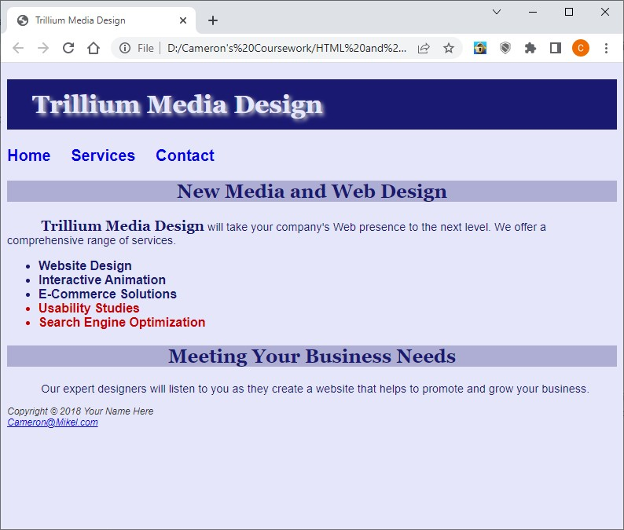

HOP 3.7

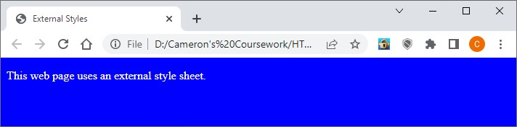

HOP 3.8

HOP 3.9

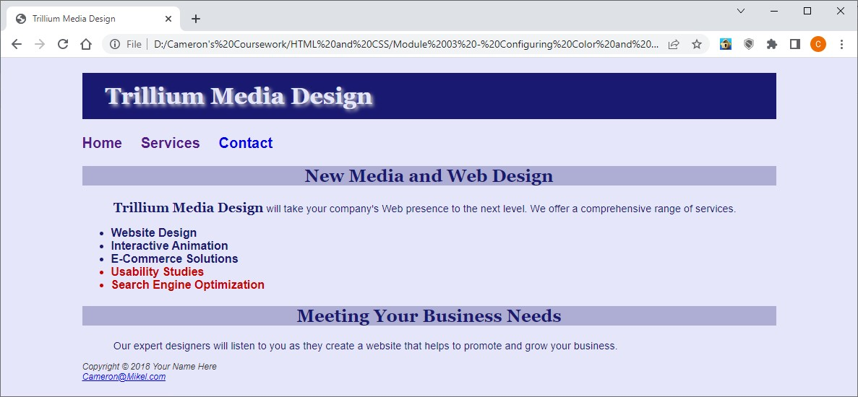

HOP 3.10

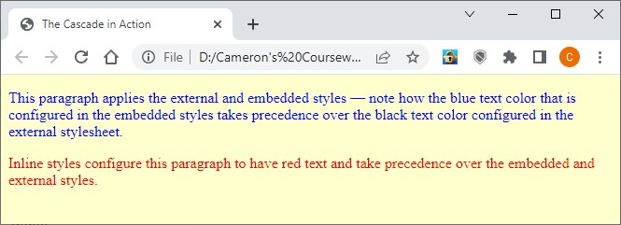

HOP 3.11 w/errors

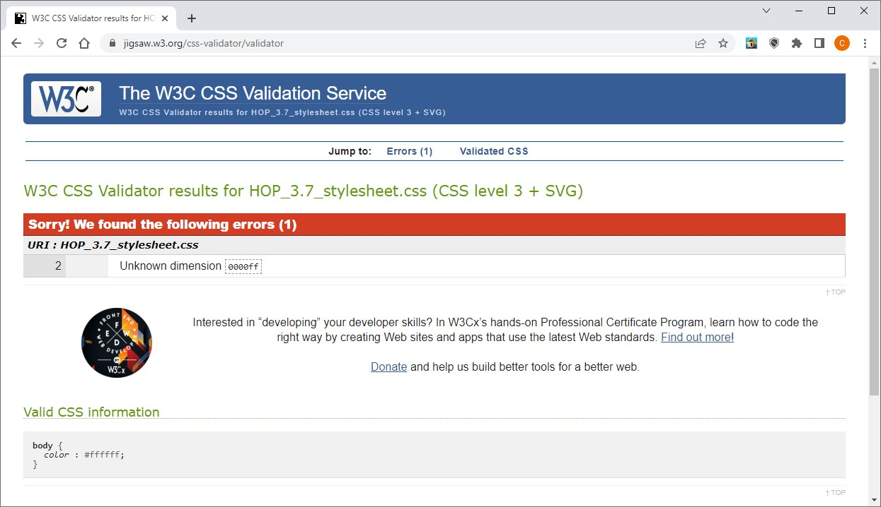

HOP 3.11 w/no errors

